**Design Document Team 07**

**Team Members**

|  |  |  |
| --- | --- | --- |
| Ali Cope | 801-7870160 | acope.byui@gmail.com |
| Matthew Martin | 702-505-7193 | mar17132@byui.edu |
| Alvern Woods | 480-593-7746 | alvern.woods@gmail.com |
|  |  |  |

**Project Overview**

This product is designed to help users plant and grow successful gardens. This is targeted at backyard personal garden grower. The initial functionality will allow the user to determine which hardiness zone they live in based on their zip code. Additional functionality may include entering information from seed packet that will allow the user to track the growth schedule of their plants, recommend plants to plant based on their location and the season, populate alerts or reminders of gardening related tasks. The sponsor will use this app to determine planting and harvesting times, in addition to other activities, depending on our progress with our stretch goals.

**Core Features**

The user will be able to input their US based zip code, and the app will return the plant hardiness zone. This will require a data pull from an API.

**Stretch Goals**

* The app will allow users to manually enter information from the back of a seed packet, and the app will populate reminders to the user’s calendar and/or give the user an alert.
  + API pull of plant information, so that the user will not have to enter information from the back of a seed packet.
* App will tell the user with plants are currently appropriate for planting.
  + The app will instruct the user to thin, weed, or harvest, based on the point 3.

**UI Design Samples**

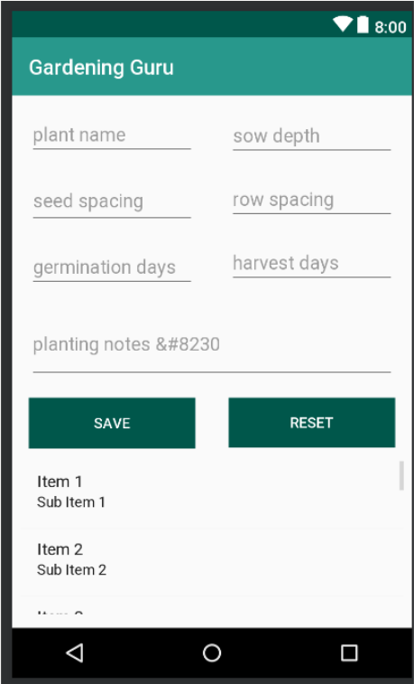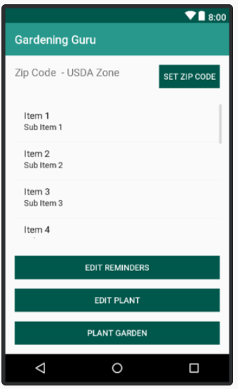

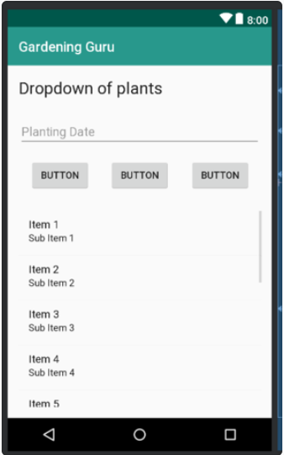

**UML** 